Game of Games Part 1: Diagrams & Use Cases

Find the Thimble Activity Diagram
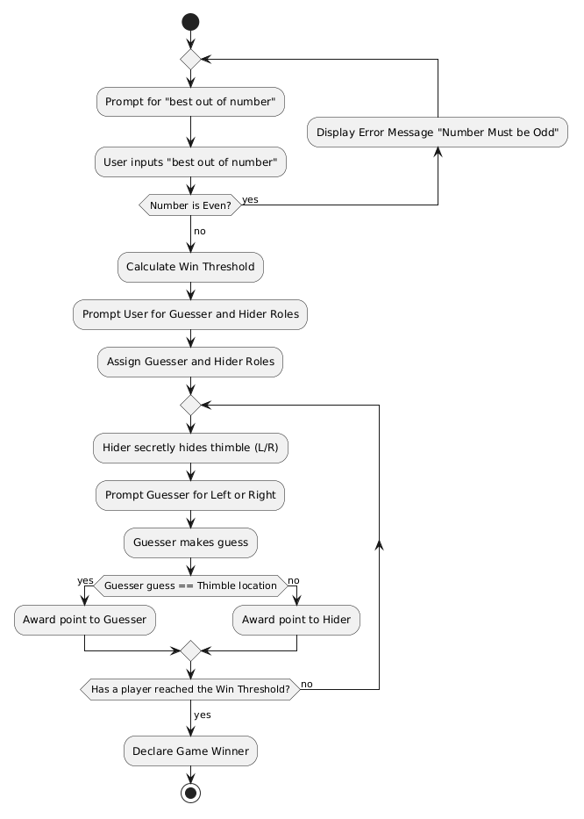

1. Use Case: Find the Thimble
- Actors: Guesser, Hider.
- Main Flow:
  - The System prompts Player 1 to specify the "best out of number".
  - Player 1 enters an odd integer.
  - The System calculates the win threshold.
  - The System prompts players to choose roles: "Who will be the Guesser?"
  - The players select whether Player 1 or Player 2 is the Guesser (the other becomes the Hider).
  - Loop Begins: The System prompts the Hider to hide the thimble secretly ('L' for Left or 'R' for Right).
  - The Hider enters 'L' or 'R' (hidden from the Guesser).
  - The System prompts the Guesser: "Which hand holds the thimble? (L/R)".
  - The Guesser enters 'L' or 'R'.
  - If the Guesser is correct, they get a point; if not, the Hider gets a point.
  - Loop Ends: The loop repeats until a player reaches the win threshold.
  - The System announces the winner.
TESTING
Sunny Day Paths
RUN | NUM | TEST | EXPECTED RESULT | ACTUAL RESULT | CORRECT | INCORRECT
 | 0 | Guess the Thimble: user gives an integer to specify the “best out of” number.  Input: Any odd integer | User is then prompted to choose roles
 | 1 | Guess the Thimble: user is prompted to choose which player will be the guesser  Input: 1 or 2 | A loop begins, prompting the hider to hide the thimble secretly
 | 2 | Guess the Thimble: the user (after being told the guesser should look away) is prompted to hide the thimble  Input: L or R | The system prompts the guesser to answer which hand holds the thimble
 | 3 | Guess the Thimble: the user (this time, the guesser) is prompted to choose the hand they think is holding the thimble  Input: L or R | If the guesser is correct, they get a point; If not, the hider gets a point. The game continues until either player’s point total reaches the threshold

Rainy Day Paths
RUN | NUM | TEST | EXPECTED RESULT | ACTUAL RESULT | CORRECT | INCORRECT
 | 4 | Guess the Thimble: user selects an even integer  Input: 4 | Error message: “Invalid menu choice. Please enter an odd integer.”
 | 5 | Guess the Thimble: user selects an integer that isn’t 1 or 2  Input: 3 | Error message:  “Invalid menu choice. Please enter 1 or 2.”
 | 6 | Guess the Thimble: user inputs a non-string or letter other than L or R  Input: W | Error message:  “Invalid input. Please enter L or R.”
 | 7 | Guess the Thimble:  user inputs a non-string or letter other than L or R  Input: A | Error message:  “Invalid input. Please enter L or R.”

Coin Flip Activity Diagram
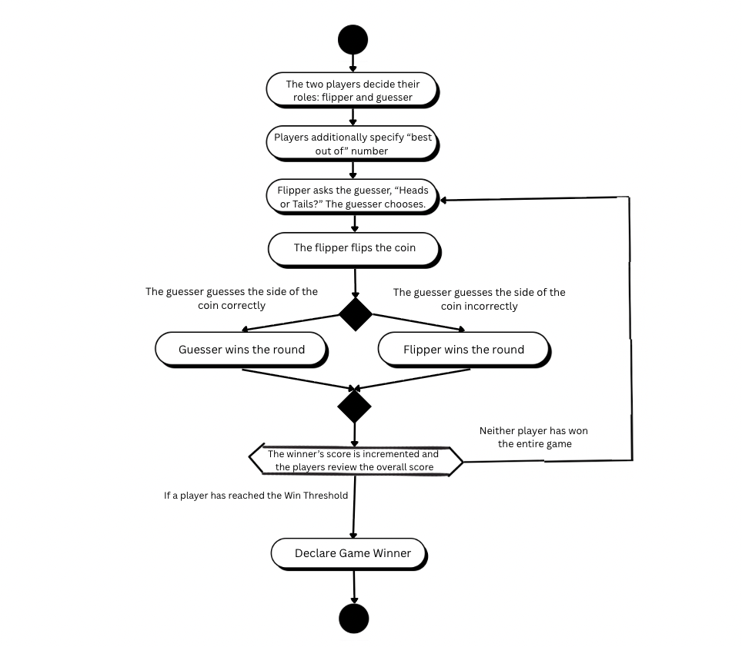

2. Use Case: Coin Flip
- Actors: Guesser, Flipper.
- Main Flow:
  - The System prompts Player 1 to specify the "best out of number" for the game.
  - Player 1 enters an odd integer.
  - The System calculates the win threshold.
  - The System prompts players to choose roles: "Who will be the Guesser?"
  - The players select whether Player 1 or Player 2 is the Guesser (the other defaults to Flipper).
  - Loop Begins: The System prompts the Guesser to call the flip: "Enter 'H' for Heads or 'T' for Tails".
  - The Guesser enters 'H' or 'T'.
  - The Flipper initiates the flip, and the System randomly generates and displays the result.
  - The System compares the Guesser's choice to the result. If it matches, the Guesser gets a point; if not, the Flipper gets a point.
  - Loop Ends: The loop repeats until a player reaches the win threshold.
  - The System announces the winner of the game.

TESTING
Sunny Day Paths
RUN | NUM | TEST | EXPECTED RESULT | ACTUAL RESULT | CORRECT | INCORRECT
 | 8 | Coin Flip: user gives an integer to specify the “best out of” number.  Input: Any odd integer | User is then prompted to choose roles
 | 9 | Coin Flip: user is prompted to choose which player will be the guesser  Input: 1 or 2 | A loop begins, prompting the guesser to call the flip
 | 10 | Coin Flip: the user (specifically the guesser) is prompted to choose heads or tails  Input: H or T | System prompts the user to flip the coin
 | 11 | Coin Flip: the user is prompted whether or not to flip the coin  Input: Y or N | If yes, the system randomly generates and displays the result. If the guesser is correct, they get a point; If not, the flipper gets a point. The game continues until either player’s point total reaches the threshold.  If no, program terminates and winner is whoever has the most amount of wins.

Rainy Day Paths
RUN | NUM | TEST | EXPECTED RESULT | ACTUAL RESULT | CORRECT | INCORRECT
 | 12 | Coin Flip: user selects an even integer or non-integer  Input: 8 | Error message: “Invalid menu choice. Please enter an odd integer.”
 | 13 | Coin Flip: user selects an integer that isn’t 1 or 2 or a non-integer  Input: H | Error message:  “Invalid menu choice. Please enter 1 or 2.”
 | 15 | Coin Flip: user inputs an non-string or letter other than H or T  Input: W | Error message:  “Invalid input. Please enter H or T.”
 | 15 | Coin Flip:  user inputs an non-string or letter other than Y or N  Input: D | Error message:  “Invalid input. Please enter Y or N.”
Guess the Number Activity Diagram
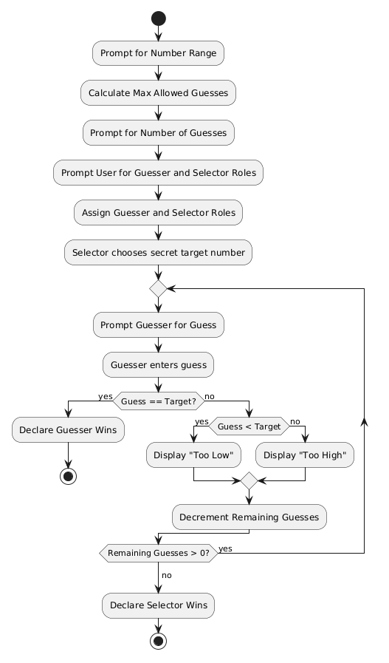
3. Use Case: Guess the Number
- Actors: Guesser, Number Selector.
- Main Flow:
  - The System prompts Player 1 to specify the maximum value for the number range.
  - Player 1 enters the maximum value.
  - The System calculates the maximum allowed guesses (half the range).
  - The System prompts for the desired number of guesses. Player 1 enters a valid number.
  - The System prompts players to choose roles: "Who will be the Guesser?"
  - Players choose roles. The other player becomes the Number Selector.
  - The Number Selector secretly enters a target number within the range (If the Selector is the Computer, it generates one randomly).
  - Loop Begins: The System prompts the Guesser: "Enter your guess".
  - The Guesser enters a number.
  - The System checks the number. If correct, the Guesser wins immediately. If incorrect, the System states whether the target is higher or lower, and decrements remaining guesses.
  - Loop Ends: The loop repeats until the Guesser gets it right or runs out of guesses.
  - The System announces the winner (Selector wins if Guesser runs out of guesses).
TESTING
Sunny Day Paths
RUN | NUM | TEST | EXPECTED RESULT | ACTUAL RESULT | CORRECT | INCORRECT
 | 16 | Guess the Number, user enters a valid maximum range value. Input: 20 | System accepts the value, calculates maximum allowed guesses (10), and prompts for desired number of guesses.
 | 17 | Guess the Number, user enters a valid number of guesses within the allowed maximum. Input: 5 | System accepts the value and prompts players to choose roles (Guesser / Number Selector).
 | 18 | Guess the Number, Guesser correctly identifies the target number. Input: An integer equal to the Number Selector's chosen target. | System announces Guesser wins immediately.
 | 19 | Guess the Number, Guesser correctly identifies the target on the final remaining guess. Input: A correct integer on the last allowed attempt. | System announces Guesser wins; no further guesses are prompted.
 | 20 | Guess the Number, Guesser's guess is below the target. Input: An integer less than the Number Selector's target. | System responds "Higher" and decrements remaining guesses by 1.
 | 21 | Guess the Number, Guesser's guess is above the target. Input: An integer greater than the Number Selector's target. | System responds "Lower" and decrements remaining guesses by 1.
 | 22 | Guess the Number, Guesser exhausts all guesses without finding the target. Input: A series of incorrect integers using all remaining guesses. | System announces Number Selector wins and reveals the target number.

Rainy Day Paths
RUN | NUM | TEST | EXPECTED RESULT | ACTUAL RESULT | CORRECT | INCORRECT
 | 23 | Guess the Number, user enters a non-integer maximum range value. Input: abc | Error message prompting user to re-enter a valid integer; program does not crash.
 | 24 | Guess the Number, user enters a maximum range value ≤ 0. Input: 0 | Error message prompting user to enter a positive integer; program does not crash.
 | 25 | Guess the Number, user enters a number of guesses exceeding the allowed maximum. Input: 15 (when max range is 20, allowed max guesses is 10). | Error message indicating guesses exceed the allowed maximum and prompting for re-entry.
 | 26 | Guess the Number, user enters a non-integer number of guesses. Input: abc | Error message prompting user to enter a valid integer; program does not crash.
 | 27 | Guess the Number, Guesser enters a number outside the valid range. Input: An integer greater than the specified maximum (e.g., 25 when max is 20). | Error message indicating the guess is out of range; remaining guesses are not decremented.
 | 28 | Guess the Number, Guesser enters a non-integer guess. Input: abc | Error message prompting Guesser to enter a valid integer; remaining guesses are not decremented.

Even and Odd Activity Diagram
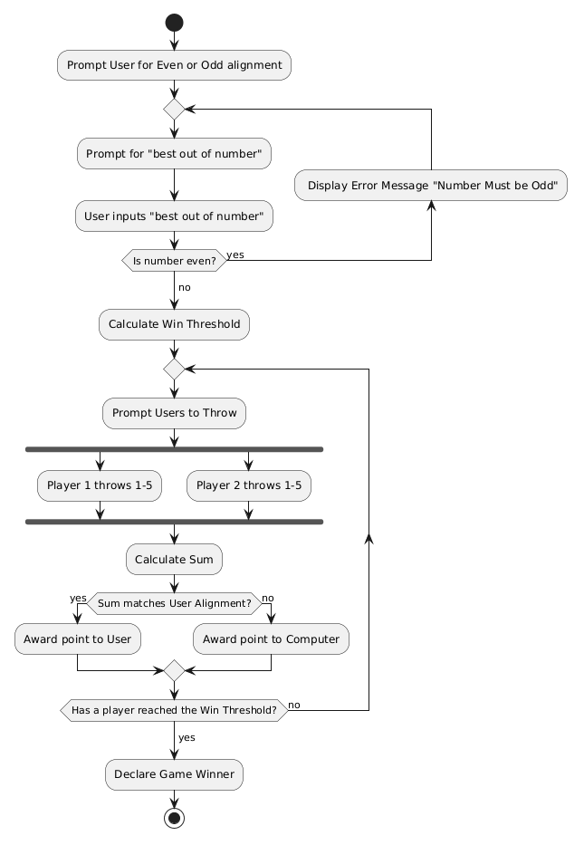
4. Use Case: Even and Odd
- Actors: Player 1, Player 2.
- Main Flow:
  - The System asks Player 1 to choose their alignment: "Even (E) or Odd (O)?". Player 2 gets the remaining alignment.
  - The System prompts for the "best out of number" (must be odd) and calculates the win threshold.
  - Loop Begins: The System prompts Player 1 to "throw" a number from 1 to 5.
  - Player 1 enters a number secretly.
  - The System prompts Player 2 to "throw" a number from 1 to 5.
  - Player 2 enters a number.
  - The System reveals both throws and calculates the sum.
  - If the sum matches Player 1's alignment, Player 1 gets a point. Otherwise, Player 2 gets a point.
  - Loop Ends: The loop repeats until a player reaches the win threshold.
  - The System announces the winner.

TESTING
RUN | NUM | TEST | EXPECTED RESULT | ACTUAL RESULT | CORRECT | INCORRECT
 | 29 | Correctly Choosing Even or Odd Alignment for Player 1 (1 or 2)  Input: 2 | Saves the choice and prompts user to indicate the number of matches.  Output: “How many matches would you like to play?”
 | 30 | Incorrectly Choosing Even or Odd alignment  Input: 5 | Displays an error message and loops back to ask for new alignment.  Output: “You have made an incorrect pick!”
 | 31 | Correctly imputing a number of matches  Input: 5 | Saves choice, calculates the winning threshold, starts match 1 and prompts users to input their throw:  Output: “Please input the throw for player (1-5):”
 | 32 | Incorrectly imputing a number of matches  Input: 4 | Displays an error message and loops back to ask for new number of matches.  Output: “Number of matches should be odd.” Please input an odd number”
 | 33 | Player 1 inputs a correct throw (1-5)  Input: 3 | Saves throw and prompts player 2 to input their throw  Output: “Please input the throw for player (1-5):”
 | 34 | Player 2 inputs a correct throw (1-5)  Input: 2 | Calculates winner of the match and displays it.  Output: “Player X has won this match”
 | 35 | Any player inputs an incorrect throw  Input: 8 | Displays an error message and loops back to ask for new throw.  Output: “Throw out of range. Input a new throw”

Find the Red Thread Activity Diagram
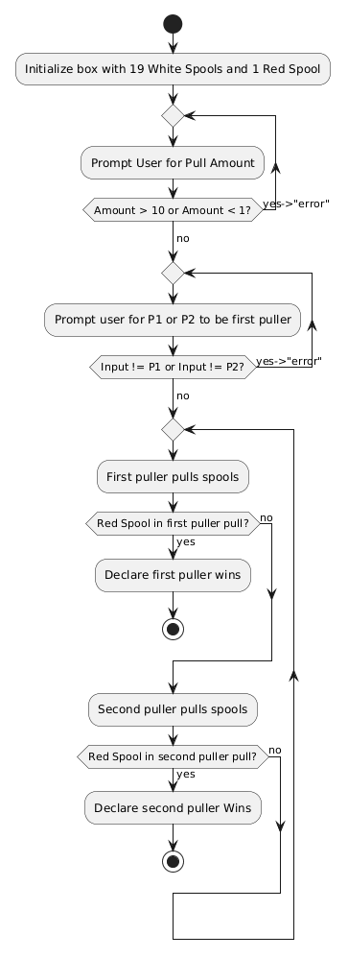
5. Use Case: Find the Red Thread
- Actors: Player 1, Player 2.
- Main Flow:
  - The System asks Player 1 how many spools to pull at a time (Max 10).
  - Player 1 enters a valid number.
  - The System asks who will pull first. Players choose Player 1 or Player 2.
  - Loop Begins: The current active player pulls the specified number of spools.
  - The System checks the pulled spools. If the red spool is found, the active player wins immediately.
  - The turn passes to the other player.
  - Loop Ends: The loop repeats until the red thread is found.
TESTING
Sunny Day Paths
RUN | NUM | TEST | EXPECTED RESULT | ACTUAL RESULT | CORRECT | INCORRECT
 | 36 | Red Thread: user gives an integer for # of spools to pull at a time from 1 to 10  Input: any integer from 1 to 10 | User is then asked to select if P1 or P2 chooses first
 | 37 | Red Thread: user decides to have P1 choose first  Input: P1 | Game loop begins with P1 having the first pull
 | 38 | Red Thread: user decides to have P2 choose first  Input: P2 | Game loop begins with P2 having the first pull
 | 39 | Red Thread: a red thread is pulled by either player | “____ (P1 or P2) wins” and game loop terminates. Returned to main menu

Rainy Day Paths
RUN | NUM | TEST | EXPECTED RESULT | ACTUAL RESULT | CORRECT | INCORRECT
 | 40 | Red Thread: User selects an incorrect pull amount (something other than an integer 1-10)  Input: 12 | Error message “error: enter an integer 1 to 10”and user will give input again
 | 41 | Red Thread: user incorrectly inputs which player will choose first  Input: Player 5 | Error message “error: enter P1 or P2” and user will give another input

Overall Game Loop Activity Diagram
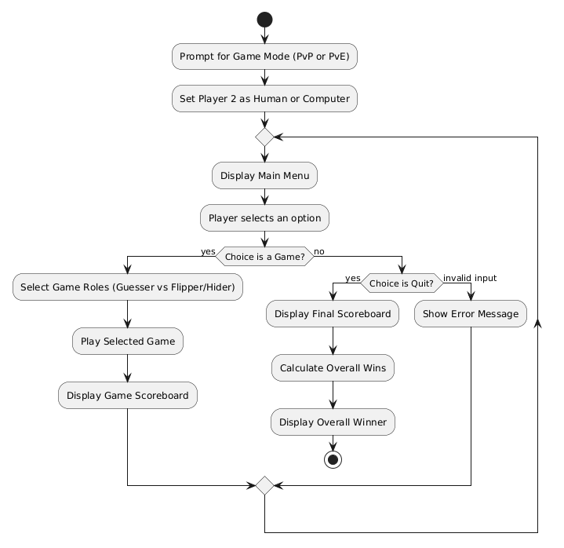6. Use Case: Overall Game of Games
- Actors: Player 1, Player 2 (Can be Human or Computer).
- Preconditions: The program is launched.
- Main Flow:
  - The System prompts the user to select a game mode: "1. Player vs Player" or "2. Player vs Computer".
  - Player 1 enters their choice. The System assigns the Player 2 role to either a human or the computer.
  - The System displays a main menu listing the five available games and a "Quit" option.
  - Player 1 enters the number corresponding to their choice.
  - The selected game executes (acts as a black box at this level).
  - Upon completion of the game, the System displays the scoreboard indicating the wins and losses for that specific game.
  - The flow returns to Step 3.
- Alternative Flow (Quit):
  - A player selects "Quit" from the main menu.
  - The System displays a final tally of the overall number of games won and lost by each player.
  - The System evaluates the totals and displays a message announcing the overall winner.
TESTING
Sunny Day Paths
RUN | NUM | TEST | EXPECTED RESULT | ACTUAL RESULT | CORRECT | INCORRECT
 | 42 | Overall Game Loop, user selects Player vs. Player mode. Input: 1 | System assigns Player 2 as a human player and displays the main menu.
 | 43 | Overall Game Loop, user selects Player vs. Computer mode. Input: 2 | System assigns Player 2 as the computer and displays the main menu.
 | 44 | Overall Game Loop, user selects Find the Thimble from the main menu. Input: 1 | Find the Thimble game launches.
 | 45 | Overall Game Loop, user selects Coin Flip from the main menu. Input: 2 | Coin Flip game launches.
 | 46 | Overall Game Loop, user selects Guess the Number from the main menu. Input: 3 | Guess the Number game launches.
 | 47 | Overall Game Loop, user selects Even and Odd from the main menu. Input: 4 | Even and Odd game launches.
 | 48 | Overall Game Loop, user selects Find the Red Thread from the main menu. Input: 5 | Find the Red Thread game launches.
 | 49 | Overall Game Loop, scoreboard displays correctly after a game concludes. Win any game once. | System displays wins and losses for that specific game, then returns to the main menu.
 | 50 | Overall Game Loop, user selects Quit and final per-game tally is displayed. Input: 6 | System displays the total number of games won and lost by each player across all games.
 | 51 | Overall Game Loop, user selects Quit and the overall winner is announced. Input: 6 | System evaluates the totals and announces an overall winner.

Rainy Day Paths
RUN | NUM | TEST | EXPECTED RESULT | ACTUAL RESULT | CORRECT | INCORRECT
 | 52 | Overall Game Loop, user enters a game mode selection out of the valid range. Input: 3 | Error message prompting user to re-enter a valid game mode (1 or 2); program does not crash.
 | 53 | Overall Game Loop, user enters a non-integer game mode selection. Input: abc | Error message prompting user to re-enter a valid integer game mode; program does not crash.
 | 54 | Overall Game Loop, user enters a main menu choice below the valid range. Input: 0 | Error message: "Invalid menu choice. Please enter an integer between 1-6."
 | 55 | Overall Game Loop, user enters a main menu choice above the valid range. Input: 7 | Error message: "Invalid menu choice. Please enter an integer between 1-6."
 | 56 | Overall Game Loop, user enters a non-integer main menu choice. Input: x | Error message prompting user to enter a valid integer between 1-6; program does not crash.

Meeting Notes, Project: Game of Games Part 2

Meeting Number:  2 | Meeting Date:  4/14/2026 | Start Time:  4:00 PM | End Time:  5:30

Attendee Name (Indicate note taker with *) | Timeliness (on time, late, left early, missing)
Ben Lyons | On time
Juan Marcano Cuellar | On time
Sean Balbale* | On time
Abby Gomes | On time

Purpose:
- Complete Part 2 of Game of Games by developing, combining, and refining test cases for each implemented game

Agenda:
- Review individually completed test cases prior to the meeting
- Combine test cases into a single unified document
- Discuss any inconsistencies or gaps in coverage across games
- Edit and finalize test cases as a group

Major Accomplishments:
- Successfully merged all individually developed test cases into one cohesive document
- Identified and resolved inconsistencies in test logic across group members' work
- Finalized a complete, reviewed set of test cases for each game

Next Steps:
- Use finalized test cases to validate the implemented game logic in Part 3
- Address any edge cases that surface during actual code execution

Meeting Notes:
The meeting started in the library. Since everyone had finished their test cases beforehand, we spent the time combining and reviewing rather than building from scratch.
We went around and walked through each person's work game by game. As people presented, we talked through the logic, caught any overlap, and sorted out spots where we'd made different assumptions about how a game should behave.
Once we were all on the same page, we pulled everything into one document. Where two people covered the same case, we kept whichever was more thorough and folded in anything unique from the other. Anything missing — mostly boundary conditions and bad input handling — we wrote together on the spot.
We wrapped up by going through the combined document and cleaning up the formatting and naming so everything was consistent and lined up with the diagrams and use cases from Part 1.

Documents: (included or links to them)

GameOfGames1_BenSeanJuanAbby

Meeting Notes, Project: Game of Games Part 1

Meeting Number:  1 | Meeting Date:  4/7/2026 | Start Time:  5:30 PM | End Time:  7:00

Attendee Name (Indicate note taker with *) | Timeliness (on time, late, left early, missing)
Ben Lyons* | On time
Juan Marcano Cuellar | On time
Sean Balbale | On time
Abby Gomes | On time

Purpose:
- Complete part 1 of game of games by creating specific diagrams to implement the programs via code in future parts

Agenda:
- Plan out how each game will flow
  - Discuss ambiguities among the games
- Create each game’s respective diagram
- Develop the use cases

Major Accomplishments:
- Created neat diagrams for every game
- Created each diagram’s corresponding use case documentation to prepare for coding

Next Steps:
- Translate the games’ diagrams/use cases into functioning code

Meeting Notes:
The meeting begins at 4:30 PM in the library. We begin by discussing how each game is played. Any ambiguities/uncertainties regarding how games are played are cleared up and agreed upon (as we all clarify how each game is played).

Next is the creation of the diagrams. We divide up who should make each diagram. Used PlantUML or Canva to efficiently create neat diagrams of how each game will flow considering two players should play it (even though when implemented, the player will only play against the computer). We put these into a document and labeled them accordingly.

Next for our use cases, we wrote them to follow the logic from our game diagrams, distinguishing unique roles players may have in a game and how each main game flows. We then put them into the same document.

Documents: (included or links to them)

GameOfGames1_BenSeanJuanAbby

